**Case- Anand Bhojanalay: The curious case of chronic attrition**

1. **How much additional cost, due to salary hikes, can Mr. Khatri expect to be incurred during the wedding season?**

As per the case, the leaving employees demand variable hike rates as per the distribution given in the case exhibits. Therefore we need to simulate this condition where different employees accept different hikes, staying or leaving upon successful negotiation with the management. There are three rounds of **simulation** for each month to be done:

(i) Simulation of employee attrition - the attrition rate is taken as the average attrition rate for that month in the past three years and hence follows a uniform distribution. It can be simulated using a random number generator in Excel.

(ii) Simulation of employees demanding hike rates - the hike rate demanded by different types of employees (Chefs, Waiters & Cleaning Staff) according to the triangular distribution based on hikes offered by catering services. The rationale is we will match the hikes given by the catering services. To simulate this, Crystal Ball can be used.

(iii) Simulation of employees staying - We have the retention rate of employees based on the average of that month in the past three years. Based on this rate, we can simulate successful negotiations and employees staying back instead of leaving. This can be done in Excel in the same way as attrition simulation.

The resulting total costs of giving hikes for all three months and cumulatively for the season can be defined as forecast in Crystal Ball. Upon simulating it for 5000 trials, we can get a normal distribution of costs. Upon analyzing the distribution, we find that there is a 90% chance that Mr. Khatri can incur Rs. 95,755.74 at max as extra costs for giving hikes to retain leaving employees.

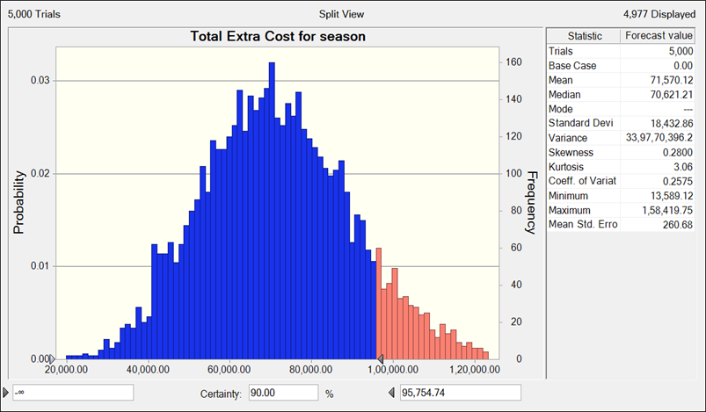

*Refer to Sheet* ***G3T04-1***

1. **Considering the uncertainty of increased customer demand and employee preferences for salary hikes, how many employees can Mr. Khatri expect to leave during the wedding season?**

As we have already simulated the situation of employee attrition, retention, and hike rate accepted, we can use the **Data table** in Excel to run the simulation for 5000 trials and get an average number of employees (type-wise) that will leave or stay back after accepting hikes for each month and for the overall season.

Referring to sheet ***G3T04-2***, the following are the results:

|  |  |  |  |  |  |  |  |  |
| --- | --- | --- | --- | --- | --- | --- | --- | --- |
| **Employee Attrition for the entire Season** | | | | | | | | |
| **Nov** | | | **Dec** | | | **Jan** | | |
| **Leaving** | **Stayed** | **Left** | **Leaving** | **Stayed** | **Left** | **Leaving** | **Stayed** | **Left** |
| 17 | 6 | 11 | 18 | 7 | 11 | 13 | 6 | 7 |

The final combined table containing the number of employees left in each month:

|  |  |  |  |  |
| --- | --- | --- | --- | --- |
| **Employee** | **Left in Nov** | **Left in Dec** | **Left in Jan** | **Total Left** |
| Chef | 2 | 3 | 1 | 6 |
| Waiter | 5 | 5 | 2 | 12 |
| Cleaning staff | 4 | 3 | 3 | 10 |

1. **Anand Bhojanalay wants to optimize the total costs of hiring manpower by optimizing the temporary salary hikes and the cost incurred in hiring new employees. What should be their hiring strategy for the month of November so that the average monthly profit is maximized?**

As discussed in the case, doing the analysis for the month of November.

Anand Bhojanalay faces two major options in this case - “To retain as many employees as possible and hire the remaining employees according to one of the two policies” or “To not retain any leaving employees and hire according to one of the two policies”. Also, there are factors that affect the payoff in each case:

(i) Growth in Demand: During the wedding season, there is a 70% chance that the restaurants will see growth in demand by 20%; hence the average monthly profit will increase.

(ii) Productivity Inefficiency Factor: When the hiring is done during the season, the new hires work at 85% efficiency of existing trained employees. Since the monthly profit can be related to the number of employees using the “Profit per Employee” Ratio, the monthly profit will depend on the number of new hires in that month.

The costs involved in comparing the two alternatives are-

(i) The cost of Increment incurred to retain certain employees in option 1. This cost can be taken from the simulation done earlier. We are taking Rs 34,680.76 (Refer to sheet ***G3T04-3***) as the cost of increment for November, which is the maximum cost that can be incurred with a 90% chance.

(ii) The cost of hiring new employees to maintain the standard levels according to the two policies. These costs are given in the case - Rs 22,000 for Chefs, Rs 15,000 for Waiters, and Rs 8,000 for cleaning staff.

The following is the **Decision tree** that will be formed for the situation:

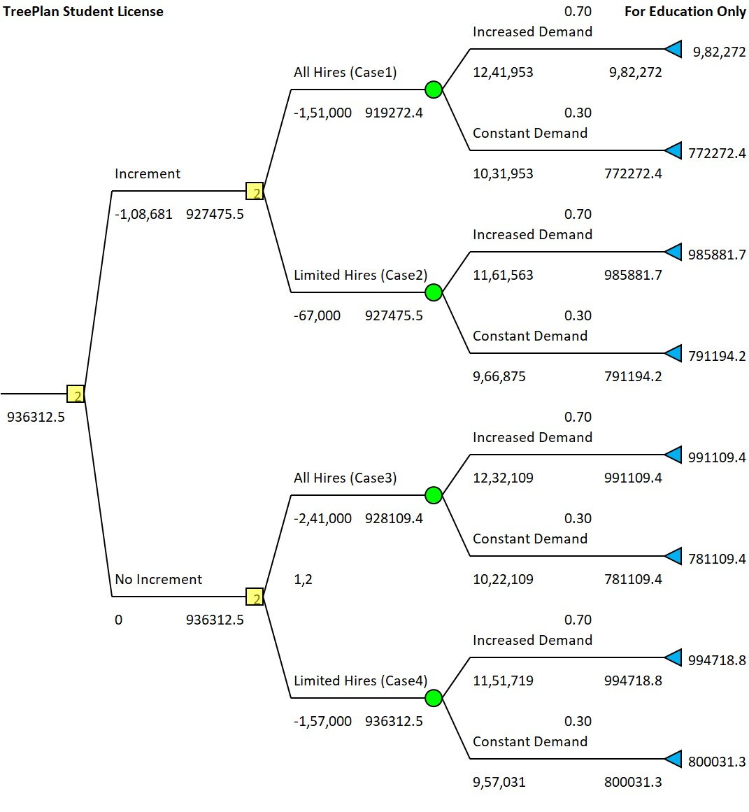

According to the decision tree, the decision with the maximum payoff in terms of average profit is:

**Do not give Increments —> Follow the Limited hire policy**

This decision allows for an expected possible payoff of Rs 9,36,313 in the current situation. If the demand increases, then the payoff can increase to Rs 9,94,719; otherwise, if the demand actually remains constant, then the payoff will be Rs 8,00,031.

1. **Which parameters have the most significant impact on payoffs and Mr. Khatri’s decision-making, aiding in hiring strategy refinement?**

Based on the tornado and spider diagrams created from the decision tree (Refer to sheet ***G3T04-3***), the parameters that exhibit the highest swing values are the parameters that have the most impact on the payoffs. They indicate the largest variations in the final payoff when they are changed.

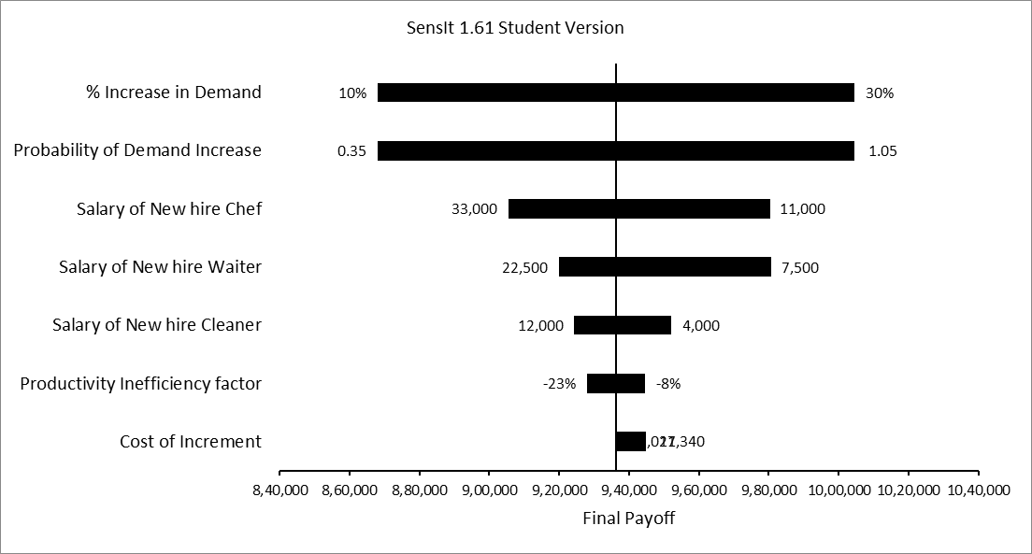

**(i) % Increase in Demand:** This parameter has the highest swing value of 39.1%. It means that a change in the percentage increase in demand for the restaurant has a significant impact on the final payoff. A higher increase in demand positively affects the payoff.

**(ii) Probability of Demand Increase:** Similar to the % Increase in Demand, this parameter also has a high swing value of 39.1%. The probability of an increase in demand plays a crucial role in shaping the hiring strategy and has a substantial impact on the final payoff.

**(iii) Salary of New Hire Chef:** The swing value for this parameter is 11.8%. The salary offered to new-hire chefs significantly affects the final payoff. Higher salaries lead to increased costs, which influence the overall outcome.

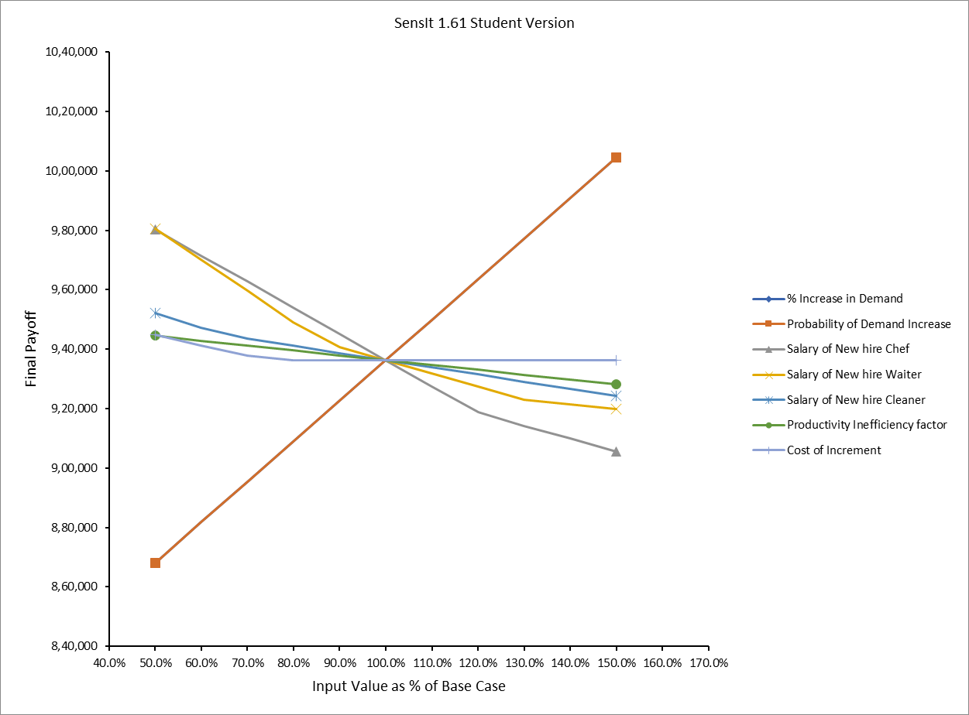

Variations in the salaries of new chefs, waiters, and cleaning staff, and cost of increment. have a substantial impact on the final decision-making. This suggests that at this salary threshold, the cost of hiring new staff outweighs the cost of retaining and incrementing existing ones. Striking a balance between retaining valuable employees and managing costs is crucial in this scenario. By understanding the below thresholds, Mr. Khatri can make informed decisions to optimize employee management strategies and maximize profitability.

|  |  |  |  |
| --- | --- | --- | --- |
| **Sensitivity Analysis** | | | |
| **Parameter Name** | **Decision Change at** | **Changed Decision Sequence** | |
| Salary of New hire Chef | >26500 | Increment | Limited Hires |
| Salary of New hire Waiter | <12900 | No Increment | All Hires |
| Salary of New hire Waiter | >19450 | Increment | Limited Hires |
| Cost of Increment | <25750 | Increment | Limited Hires |
| Salary of New hire Cleaning Staff | <5250 | No Increment | All Hires |

1. **Is it viable for Mr. Khatri to refrain from providing salary increments to retain leaving employees and instead opt to recruit new employees?**

In context with the case, refraining from providing salary increments to retain leaving employees and opting to recruit new employees is a plausible option for Mr. Khatri to consider, specifically by following the "Do not give Increments —> Follow Limited hire policy" decision. This conclusion is drawn from evaluating the potential average profit and payoff associated with both alternatives. Considering the costs involved, such as the cost of increment to retain employees (Rs 34,691.37) and the cost of hiring new employees according to the limited hire policy, the decision tree analysis suggests that refraining from providing increments and recruiting new employees would lead to higher average profits.

The decision changes only when the cost of increment to retain employees is reduced to Rs 25,750 (which is the maximum cost incurred with a chance of 73.99%).

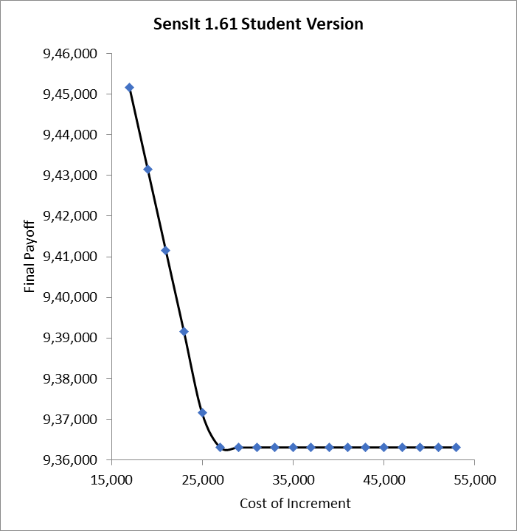

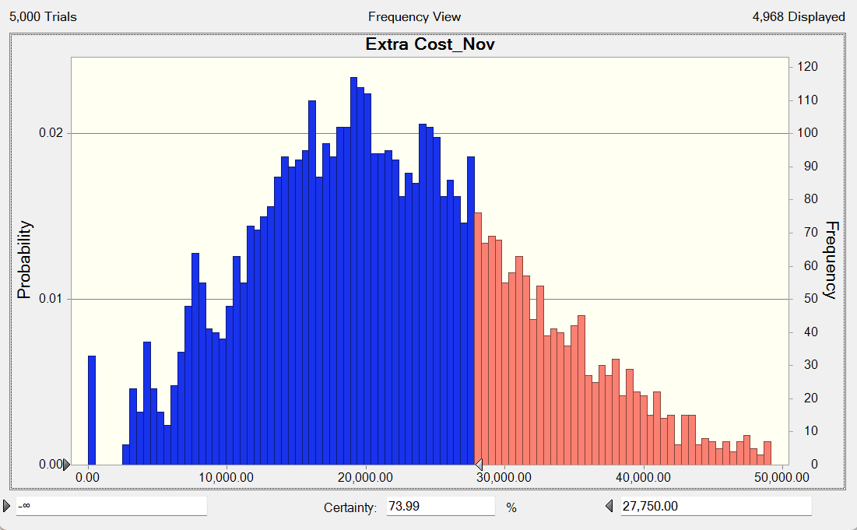

Considering the budget constraints, Mr. Khatri can strategically align salary increments with the range offered by catering services. By capping the increment for each employee based on the catering industry's standard, he can ensure a balanced budget. The overall budget for distributing hikes can be taken on the basis of the value where the decision changes, i.e., Rs 27,750, as obtained from the simulation. He can offer increments to employees until the budget is satisfied, after which he should hire new employees.

1. **What long-term benefits can Anand Bhojanalay achieve by retaining its workforce during the wedding season?**

By successfully retaining its workforce during the wedding season, Anand Bhojanalay can reap several long-term benefits that extend beyond immediate operational challenges:

**(i) Consistent Customer Experience and Customer Loyalty:** Retaining experienced staff ensures consistent service quality and customer experience. Customers familiar with the restaurant's staff and offerings are more likely to become loyal patrons, leading to repeat business. The relationships formed between long-term employees and customers can foster a sense of loyalty among patrons, leading to increased customer retention and support.

**(ii) Employee Loyalty:** Implementing effective retention strategies showcases the restaurant's commitment to its workforce. This fosters a sense of loyalty among employees, reducing turnover in the long term.

**(iii) Reduced Training Costs:** High employee turnover often requires frequent hiring and training, which incurs costs. Retaining employees reduces the need for frequent training, leading to cost savings in the long run.

**(iv) Skill Development and Expertise:** Over time, employees gain valuable skills and expertise specific to the restaurant's operations. Retaining these experienced staff members contributes to a skilled workforce that can improve overall efficiency.

**(v) Reduced Recruitment Challenges:** As the restaurant builds a reputation for valuing its employees, it can attract potential candidates looking for stable, long-term employment, making recruitment easier.

**(vi) Strategic Stability:** With a stable workforce, the restaurant can focus on strategic initiatives and innovations rather than addressing frequent hiring and training needs, contributing to long-term growth.

Overall, retaining its workforce during the wedding season can contribute to the establishment of a resilient, customer-centric, and efficient restaurant that enjoys enhanced employee loyalty, reputation, and long-term success in the competitive hospitality industry.

1. **What strategies can Anand Bhojanalay explore to minimize attrition during the wedding season?**

Anand Bhojanalay can explore several strategies to mitigate attrition during the wedding season:

**(i) Flexible Work Arrangements:** Implement flexible work schedules or part-time options for employees during the peak wedding season. This could accommodate their needs while retaining their services.

**(ii) Performance-Based Incentives:** Introduce performance-based incentives that reward employees who stay committed and perform well during the wedding season, providing an additional reason to remain with the restaurant.

**(iii) Temporary Benefits:** Instead of salary hikes, offer temporary benefits like free meals, transportation, or wellness programs specifically for the wedding season. These perks can provide an incentive to stay.

**(iv) Employee Feedback Loop:** Establish an open feedback mechanism to understand employees' concerns and preferences. Tailor retention strategies based on their input to create a more engaging work experience.

**(v) Referral Programs:** Launch referral programs where current employees are rewarded for recommending suitable candidates for seasonal hiring. This can bring in new talent while boosting employee engagement.

**(vi) Recognition and Appreciation:** Regularly recognize and appreciate employees' efforts and contributions. A culture of appreciation can foster stronger connections and loyalty.

Each of these strategies can be tailored to the specific needs and culture of Anand Bhojanalay, helping to curtail attrition and create a more stable workforce during the demanding wedding season.